**Aim:** WAP in Tinkercad to develop earthquake detector using tilt sensor, LCD, Buzzer and Arduino Uno.

**Theory:**

·        **Tilt Sensor**

·        **Arduino Uno**

·        **Buzzer**

**Circuit Diagram:**

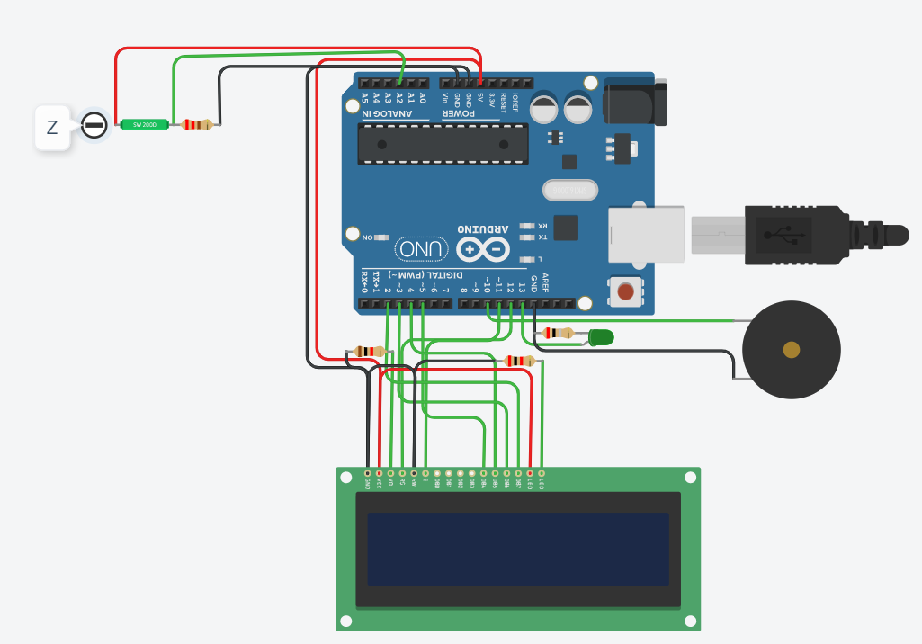

**Code:**

#include<LiquidCrystal.h> // lcd Header

LiquidCrystal lcd(12,11,5,4,3,2); // pins for LCD Connection

#define buzzer 10 // buzzer pin

#define led 13 //led pin

#define z A2 // z_out pin of Accelerometer

/*variables*/

int zsample=0;

long start;

int buz=0;

/*Macros*/

#define samples 50

#define maxVal 20 // max change limit

#define minVal -20 // min change limit

#define buzTime 5000 // buzzer on time

void setup()

{

lcd.begin(16,2); //initializing lcd

Serial.begin(9600); // initializing serial

delay(1000);

lcd.print("EarthQuake ");

lcd.setCursor(0,1);

lcd.print("Detector ");

delay(2000);

lcd.clear();

lcd.print("Calibrating.....");

lcd.setCursor(0,1);

lcd.print("Please wait...");

pinMode(buzzer, OUTPUT);

pinMode(led, OUTPUT);

buz=0;

digitalWrite(buzzer, buz);

digitalWrite(led, buz);

for(int i=0;i<samples;i++) // taking samples for calibration

{

zsample+=analogRead(z);

}

zsample/=samples; // taking avg for z

delay(3000);

lcd.clear();

lcd.print("Calibrated");

delay(1000);

lcd.clear();

lcd.print("Device Ready");

delay(1000);

lcd.clear();

lcd.print(" Z ");

}

void loop()

{

int value3=analogRead(z); //reading z out

int zValue=zsample-value3; // finding change in z

/*displying change in x,y and z axis values over lcd*/

lcd.setCursor(12,1);

lcd.print(zValue);

delay(100);

/* comparing change with predefined limits*/

if(zValue < minVal || zValue > maxVal)

{

if(buz == 0)

start=millis(); // timer start

buz=1; // buzzer / led flag activated

}

else if(buz == 1) // buzzer flag activated then alerting earthquake

{

lcd.setCursor(0,0);

lcd.print("Earthquake Alert ");

if(millis()>= start+buzTime)

buz=0;

}

else

{

lcd.clear();

lcd.print("Z");

}

digitalWrite(buzzer, buz); // buzzer on and off command

digitalWrite(led, buz); // led on and off command

/*sending values to processing for plot over the graph*/

Serial.print("z=");

Serial.println(zValue);

Serial.println(" $");

}

**Simulation Result:**

